**Hands-on Healing: Volunteering for Community Wellness at Reawakening Wellness Foundation**

# 21GNP301L - COMMUNITY CONNECT REPORT 2024-2025

*Submitted by*



**Lakshya Pratap Singh [RA2211003010780]**

*in partial fulfillment of the requirements for the degree of*

**BACHELOR OF TECHNOLOGY**

**In**

**COMPUTER SCIENCE ENGINEERING**

**DEPARTMENT OF COMPUTING TECHNOLOGIES COLLEGE OF ENGINEERING AND TECHNOLOGY**

**SRM INSTITUTE OF SCIENCE AND TECHNOLOGY**

**KATTAKULATHUR – 603203**

**OCTOBER 2024**

**SRM INSTITUTE OF SCIENCE AND TECHNOLOGY KATTANKULATHUR – 603203**

**BONAFIDE CERTIFICATE**

Certified that 21GNP301L Community Connect report titled **“Hands-on Healing:**

**Volunteering for Community Wellness at Reawakening Wellness Foundation”** is the bonafide work of **“Lakshya Pratap Singh [RA2211003010780]”** who carried out the community work under **Reawakening Wellness Foundation, B 166, Sector 108, Noida, Uttar Pradesh 201304.** Certified further, that to the best of my knowledge the work reported herein does not form any other report or dissertation on the basis of which a degree or award was conferred on an earlier.

occasion on this or any other candidate.

**Faculty Advisor**

**Dr.S.Ramesh**

**Assistant Professor**

**Department of Computing Technologies**

**Academic Advisor**

**Dr.P.Saranya**

**Associate Professor**

**Department of Computing Technologies**

**Panel Head**

**Dr.S.Ramesh**

**Assistant Professor**

**HOD**

**Dr.G.Niranjana**

**Professor and Head**

**Department of Computing Technologies Department of Computing Technologies**

**COMPLETION/ATTENDANCE CERTIFICATE**

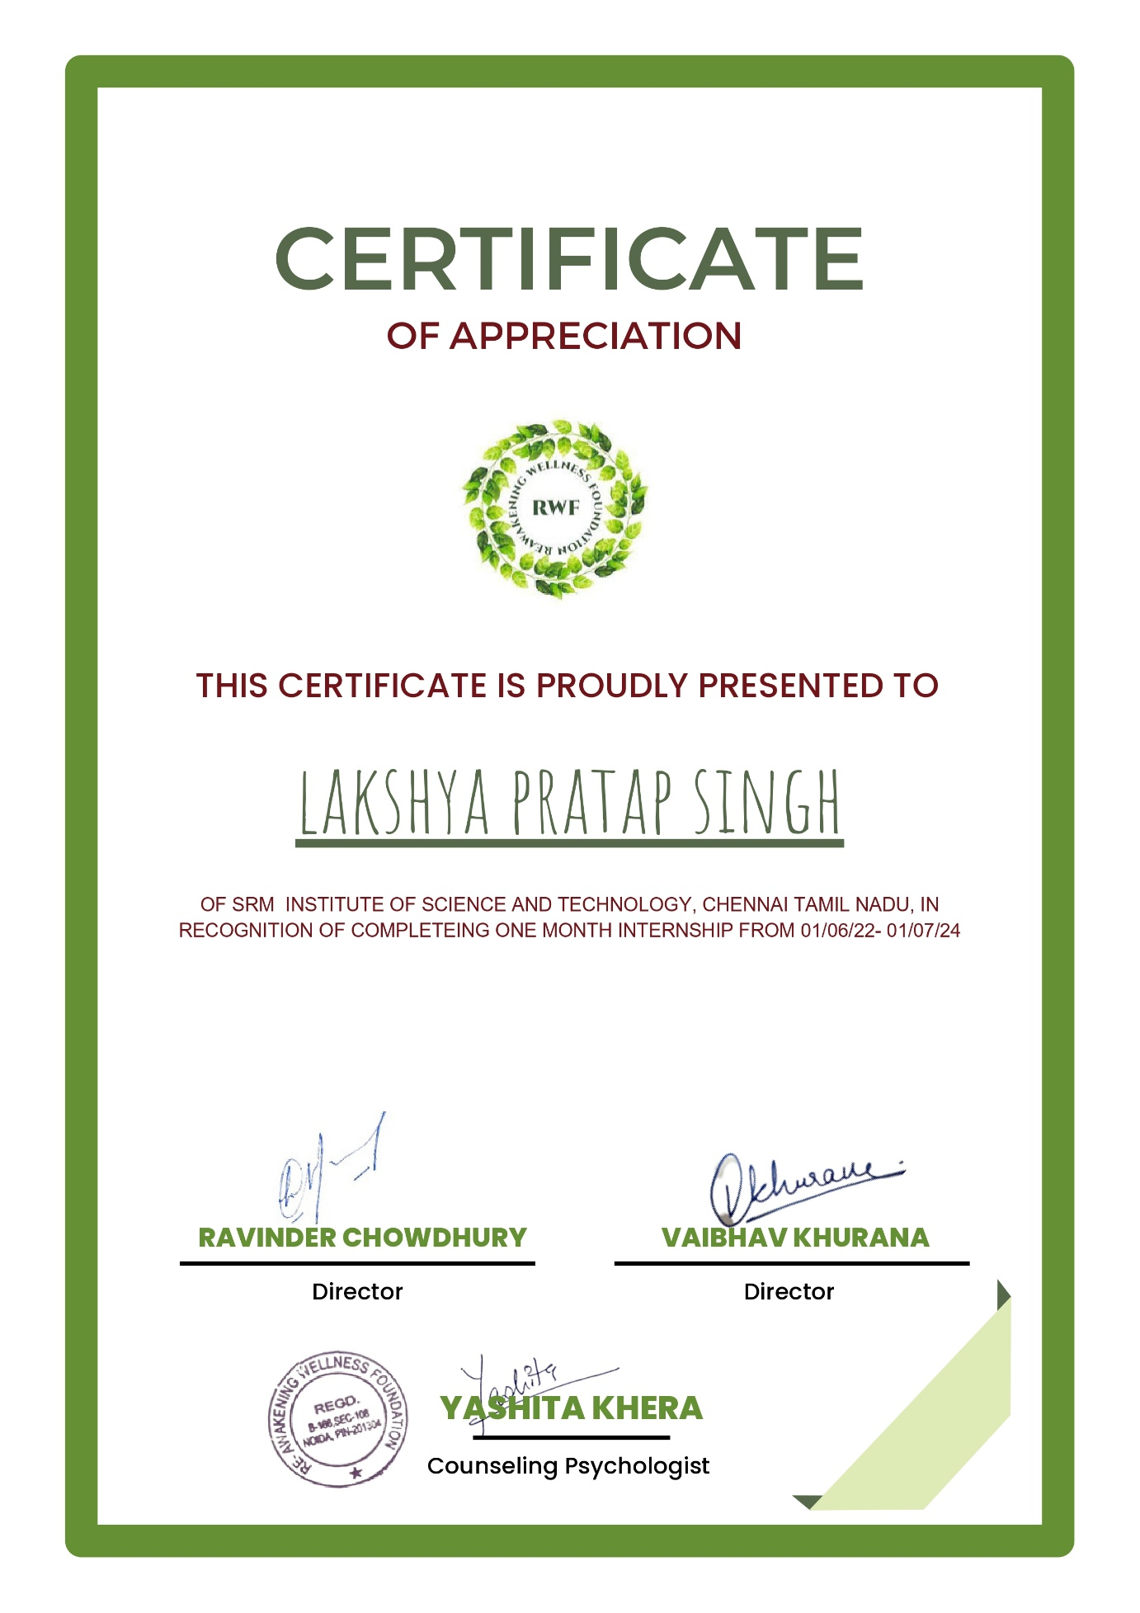

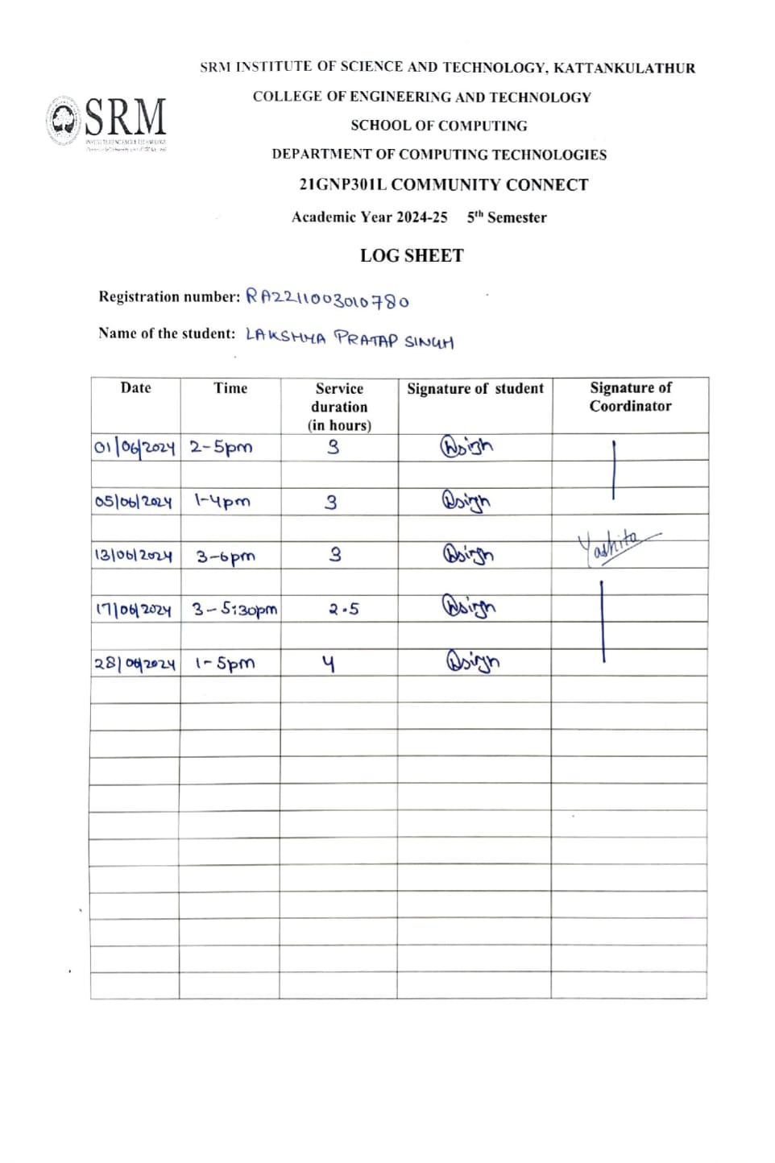

**OBJECTIVES OF THE COMMUNITY CONNECT**

The objective of this volunteering experience was to actively engage in the rehabilitation and recovery efforts of individuals within the rehabilitation center, as part of my Community Connect course. This opportunity aimed to enhance my understanding of the physical, mental, and emotional challenges faced by individuals in recovery and contribute meaningfully to their rehabilitation process. By offering direct support to both the patients and the professional staff, I hoped to make a positive impact while gaining valuable hands-on experience in community-based healthcare. One of the primary goals of this volunteering was to assist in therapeutic activities that promote the physical, emotional, and psychological well-being of the individuals in rehabilitation. This included participating in structured rehabilitation exercises, engaging in social interactions with the patients to uplift their spirits, and helping create a supportive, positive environment conducive to healing. Through these activities, I aimed to help individuals regain their sense of independence and self-worth, while also relieving some of the workload of the professional staff. Furthermore, an important aspect of this experience was to develop a deeper understanding of how multidisciplinary teams work together in rehabilitation. By collaborating with healthcare providers, social workers, and counsellors, I was able to observe how different expertise and perspectives contribute to the recovery process. This exposure allowed me to appreciate the importance of coordinated, individualized care plans and the role that community involvement plays in successful rehabilitation. Additionally, this volunteering experience aimed to foster my personal growth, particularly in areas like empathy, communication, teamwork, and patience. Working closely with individuals facing significant life challenges helped me develop emotional resilience and sharpened my problem-solving skills in a sensitive and complex environment. In conclusion, this experience bridged the gap between academic learning and real-world community service, contributing to my personal development while making a tangible difference in the lives of those I served.

**TABLE OF CONTENTS**

|  |  |  |
| --- | --- | --- |
| **S. No** | **Content** | **Page No.** |
| **1** | **INTRODUCTION OF THE ORGANIZATION** | 7-8 |
| **2** | **WEEK-WISE REPORT** | 9-19 |
| **3** | **TANGIBLE LEARNING** | 22-23 |
| **4** | **STUDENT’S CONTRIBUTION** | 24-25 |
| **5** | **CONCLUSION** | 26 |

**CHAPTER 1 INTRODUCTION OF THE ORGANIZATION**

At Reawakening Wellness (RWF), the organization is passionate about cultivating a world where mental and emotional well-being is a priority for all. As a leading non-profit organization, RWF strives to provide comprehensive wellness solutions, guiding individuals toward self-discovery and healing. The committed team of experts and compassionate volunteers work relentlessly to provide a welcoming and inclusive atmosphere in which everyone feels appreciated and empowered. RWF aims to eliminate the stigma around mental health and raise awareness in society through creative programs, workshops, and advocacy initiatives. The organization believes that every individual has the potential to succeed and is dedicated to working together to create a brighter, healthier future for all. Reawakening Wellness (RWF) is a highly esteemed non-profit residential therapeutic community that has been at the forefront of offering exceptional services in the field of mental health and rehabilitation. The organization is dedicated to providing comprehensive and compassionate care to individuals facing various mental health challenges. As a therapeutic community, RWF creates a nurturing and supportive environment where individuals can embark on their journey to recovery and rediscovery. RWF’s holistic approach focuses on treating the whole person, addressing their mental, emotional, and physical well-being. The organization firmly believes in the power of community and the transformative effects it can have on individuals seeking healing. The experienced and empathetic professionals at RWF are committed to helping young, bright, and promising individuals who may have experienced setbacks due to mental illnesses such as issues with alcohol and drugs, schizophrenia, bipolar disorder, depression, obsessive-compulsive disorder, personality disorders, and more. Understanding that these conditions can profoundly impact not only the individual but also their families, RWF extends its support to everyone involved. Since its inception in 2019, the organization has witnessed countless success stories of individuals overcoming their struggles and reclaiming their lives. Through education and self-awareness, RWF empowers its clients to recognize their thoughts and emotions and take responsibility for their recovery. RWF’s goal is to equip individuals with the necessary skills to make informed and healthy choices that lead to fulfilling and meaningful lives. The organization firmly believes that everyone deserves a chance at a better life and works tirelessly to restore hope, dignity, and self-respect to its clients and their families. RWF’s mindfulness-based therapeutic approach, combined with recovery-oriented treatment, sets the foundation for lasting positive change.

# Activities of the organization:

Reawakening Wellness Foundation (RWF) offers a wide range of therapeutic and rehabilitation services to support individuals dealing with mental health challenges. The foundation’s core activities include individualized therapy sessions, group counselling, and family therapy, all of which help individuals develop coping strategies and foster emotional healing.

RWF runs specialized rehabilitation programs aimed at assisting individuals recovering from substance abuse and mental health disorders. These programs incorporate medical detox, behavioural therapies, and relapse prevention strategies, providing a comprehensive approach to recovery.

Education is central to RWF’s mission. The foundation offers workshops and life skills training to equip individuals with the knowledge and tools needed to manage their mental health and successfully reintegrate into society. Topics include stress management, financial literacy, and vocational guidance.

Mindfulness and meditation are integral parts of RWF’s holistic approach. Daily mindfulness practices such as meditation, yoga, and relaxation exercises help individuals manage stress, improve emotional regulation, and achieve mental clarity throughout their recovery journey.

In addition to clinical interventions, RWF promotes community engagement and advocacy. Through mental health awareness campaigns, public seminars, and support groups, the foundation strives to reduce the stigma around mental health, encouraging greater understanding and support for those in need.

**CHAPTER 2**

**WEEK-WISE REPORT**

**Week 1 Report: Orientation and Introduction to Reawakening Wellness Foundation**

During the first week at Reawakening Wellness Foundation (RWF), the focus was on orientation and familiarization with the organization's mission, values, and operational structure. This initial phase was crucial for understanding the foundation's holistic approach to mental health and rehabilitation.

The week began with an orientation session led by the management team, where the core objectives of RWF were outlined. The participants were introduced to the various programs offered, including therapeutic sessions, rehabilitation initiatives, and community engagement activities. Emphasis was placed on the foundation's commitment to providing compassionate care and creating a stigma-free environment for individuals seeking help.

I had the opportunity to tour the facility, allowing me to see the different spaces utilized for therapy, group sessions, and recreational activities. This firsthand experience provided insight into the supportive and welcoming atmosphere that RWF strives to maintain.

Additionally, I attended introductory meetings with various team members, including therapists, counselors, and administrative staff. These interactions helped me understand the collaborative nature of the work and the importance of a multidisciplinary approach to rehabilitation.

During the week, I also participated in training sessions focused on understanding mental health issues, including the types of disorders treated at RWF, the significance of empathy in care, and the role of community support in recovery. These sessions equipped me with foundational knowledge to engage effectively with clients and contribute positively to the rehabilitation process.

Overall, Week 1 served as a critical foundation for my journey at Reawakening Wellness Foundation, instilling a sense of purpose and direction as I prepared to engage in the various activities and programs in the weeks to come.

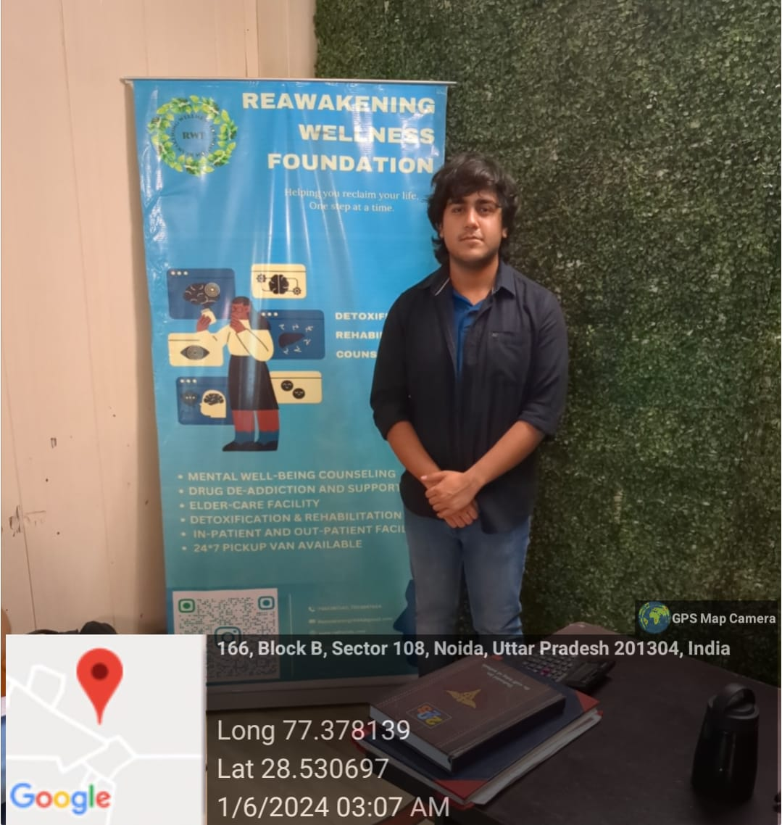

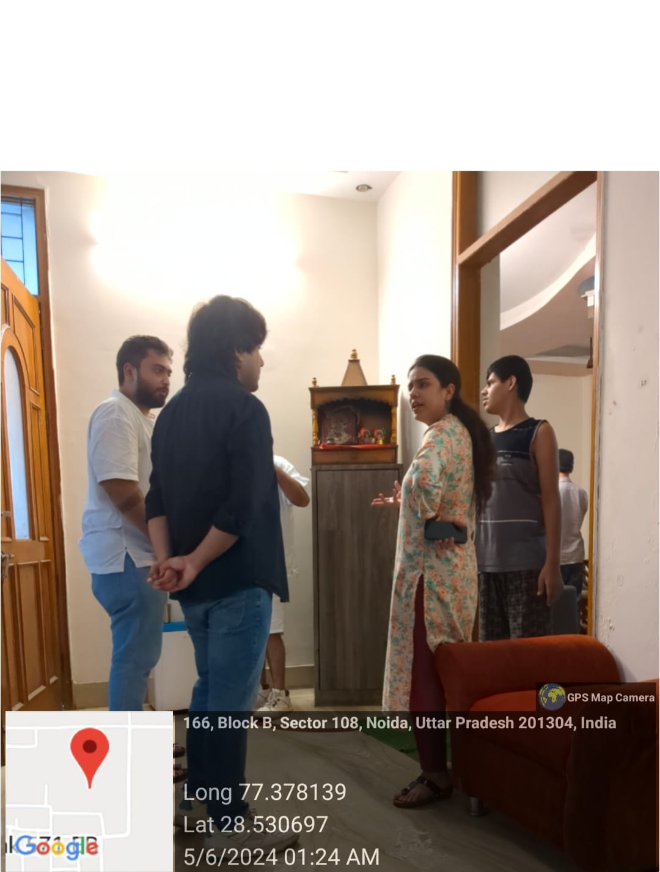

**Week 2 Report: Engaging in Therapeutic Sessions and Group Activities at Reawakening Wellness Foundation**

In the second week at Reawakening Wellness Foundation (RWF), the focus shifted toward active participation in therapeutic sessions and group activities. This week was instrumental in applying the knowledge gained during orientation and understanding the practical aspects of the foundation's therapeutic approach.

**Activities:**

1. **Observation of Individual Therapy Sessions**

The week began with observing various individualized therapy sessions, including cognitive-behavioural therapy (CBT) and mindfulness-based practices. I had the opportunity to witness the therapeutic techniques employed by licensed therapists, which emphasized building rapport and trust with clients. Observing these sessions provided valuable insights into the therapeutic process and the significance of tailoring interventions to meet each client's unique needs.

1. **Participation in Group Therapy Sessions**

Additionally, I participated in group therapy sessions designed to foster peer support and community building among clients. These sessions encouraged open dialogue and sharing of personal experiences, allowing participants to connect with one another and realize they are not alone in their struggles. I assisted the therapists in facilitating discussions, which enhanced my understanding of group dynamics and the therapeutic benefits of shared experiences.

1. **Engagement in Recreational Activities**

Throughout the week, I also contributed to recreational activities, such as art therapy and mindfulness workshops. These creative outlets allowed clients to express themselves and process their emotions in non-verbal ways. Engaging in these activities not only promoted healing but also strengthened my belief in the importance of holistic care in the rehabilitation process.

1. **Team Meetings and Case Discussions**

Furthermore, I had the chance to attend team meetings where staff members discussed client progress and collaborated on treatment plans. These meetings highlighted the collaborative nature of care at RWF and the commitment of the team to support each individual's journey to recovery.

**Key Learnings**

* **Therapeutic Techniques**: Observing individual therapy sessions provided insights into effective communication strategies and the importance of building trust with clients. I learned how therapists adapt their approaches to suit individual needs and circumstances.
* **Power of Peer Support**: Participating in group therapy illustrated the significant role of peer support in recovery. I recognized how sharing experiences can foster empathy, reduce feelings of isolation, and promote a sense of belonging.
* **Holistic Approaches**: Engaging in recreational activities reinforced the value of holistic care in mental health treatment. Creative therapies such as art and mindfulness can be powerful tools for emotional expression and healing.
* **Interdisciplinary Collaboration**: Attending team meetings emphasized the importance of collaboration among professionals in providing comprehensive care. It highlighted the necessity of sharing insights and coordinating efforts to create effective treatment plans.

Overall, Week 2 was a transformative experience that deepened my understanding of therapeutic practices and reinforced the importance of community support in mental health recovery. I felt more equipped to contribute meaningfully to the foundation's mission and looked forward to further involvement in the coming weeks.

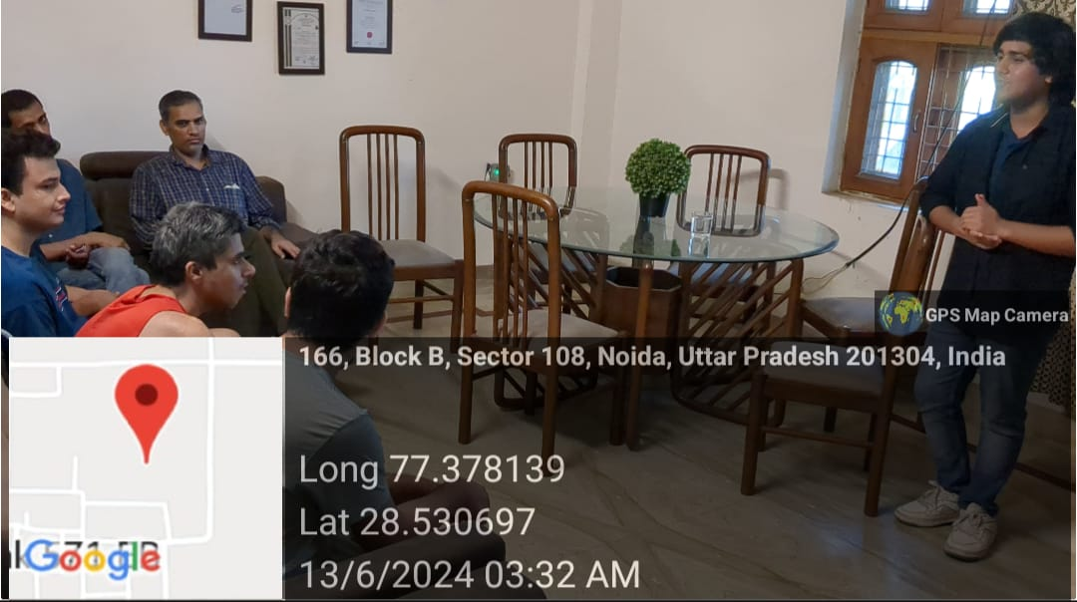

**Week 3 Report: Skill Development and Internal Workshops at Reawakening Wellness foundation**

In the third week at Reawakening Wellness Foundation (RWF), the focus was on skill development and participation in internal workshops designed to enhance therapeutic techniques and improve overall service delivery. This week provided valuable opportunities for personal growth and professional development within the organization.

**Activities:**

1. **Therapeutic Skills Workshops**

The week began with a series of workshops focused on enhancing therapeutic skills among staff and volunteers. Led by experienced professionals, these sessions covered various topics, including advanced communication techniques, empathy training, and the application of different therapeutic modalities. Participating in these workshops deepened my understanding of effective communication and the importance of empathy in fostering therapeutic relationships.

1. **Role-Playing Exercises**

I engaged in role-playing exercises designed to simulate real-life scenarios that therapists may encounter. These exercises provided a safe space to practice responses to challenging situations, such as handling difficult emotions or addressing resistance from clients. This hands-on approach reinforced the practical application of skills learned in theory and highlighted the importance of adaptability in therapy.

1. **Team-Building Activities**

To strengthen collaboration among team members, RWF organized team-building activities that encouraged trust and communication. These activities included problem-solving tasks and group discussions that allowed us to share experiences and foster a sense of camaraderie. I learned how vital teamwork is in creating a cohesive therapeutic environment where everyone feels valued and supported.

1. **Case Studies and Discussions**

Additionally, I participated in case study discussions where staff analysed real client scenarios and explored different treatment approaches. These discussions fostered critical thinking and collaborative problem-solving among team members. I appreciated the opportunity to learn from my peers and contribute my insights to develop comprehensive treatment plans.

**Key Learnings**

* **Enhancing Therapeutic Skills**: The workshops emphasized the importance of continuous skill development in therapeutic practices. I learned that ongoing education is essential for staying current with best practices and improving service quality.
* **Practical Application**: Engaging in role-playing exercises highlighted the significance of practicing skills in a supportive environment. I realized that being able to apply theoretical knowledge in real-life scenarios is crucial for effective therapy.
* **Collaboration and Teamwork**: Team-building activities reinforced the value of collaboration within the organization. I learned that strong relationships among team members enhance communication and create a supportive atmosphere for clients.
* **Critical Thinking in Treatment**: Participating in case study discussions developed my analytical skills and underscored the importance of considering multiple perspectives when addressing client needs. Understanding different approaches helps in creating tailored treatment plans.

Overall, Week 3 was a valuable experience focused on skill enhancement and teamwork. It provided me with the tools to contribute more effectively to RWF's mission and reinforced my commitment to professional growth in the field of mental health.

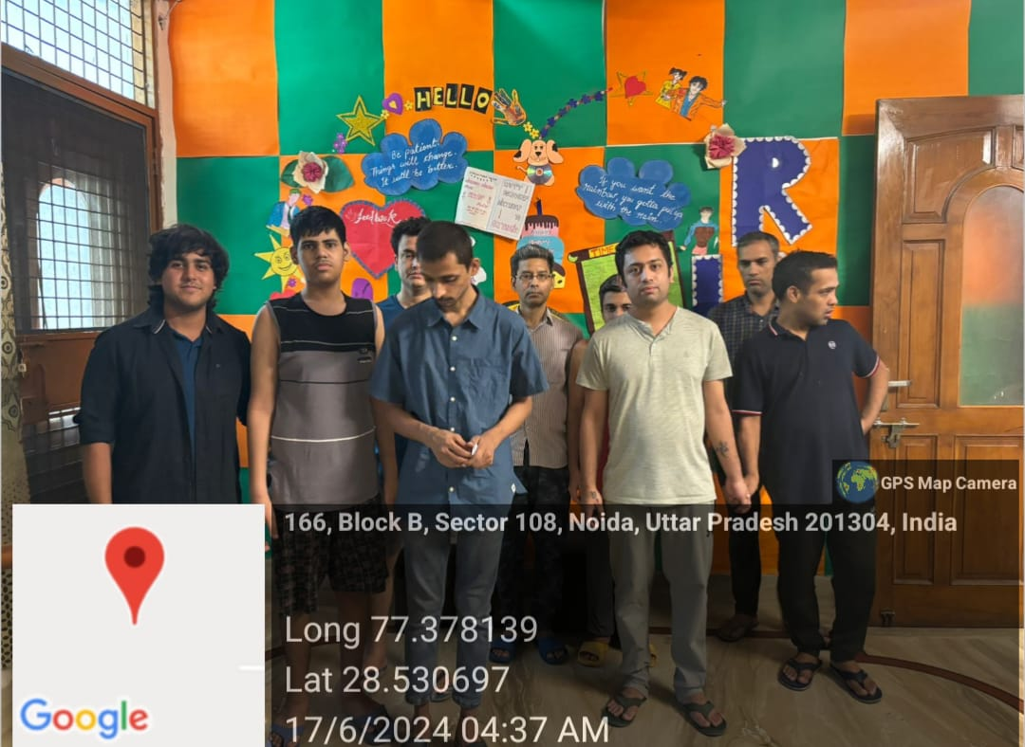

**Week 4 Report: Reflection, Feedback, and Final Contributions at Reawakening Wellness foundation**

In the final week at Reawakening Wellness Foundation (RWF), the focus was on consolidating my experience, receiving feedback, and making final contributions to the organization. This week was dedicated to reflecting on the knowledge and skills gained throughout the program, wrapping up ongoing tasks, and preparing for the next steps in my personal and professional journey.

**Activities**

1. **Final Client Interactions**

During this week, I had the opportunity to interact with clients I had worked with over the past weeks. These interactions allowed me to witness their progress and contribute to the final stages of their rehabilitation journey. It was rewarding to see the positive impact of the foundation’s holistic approach and my involvement in supporting their healing process.

1. **Feedback Sessions with Supervisors**

I participated in feedback sessions with my supervisors, where I received constructive insights on my performance and areas for improvement. These sessions were instrumental in identifying my strengths, such as effective communication and empathy, as well as areas where I could further develop, like handling complex therapeutic scenarios. The feedback helped me understand how I contributed to the foundation’s mission and prepared me for future opportunities.

1. **Completing Ongoing Tasks**

Throughout the week, I focused on completing the tasks I had been assigned, including administrative work, assisting in group sessions, and updating client records. I also contributed to finalizing reports on the progress of clients I had been involved with. Wrapping up these tasks ensured that I left the foundation with my responsibilities fulfilled and gave me a sense of accomplishment.

1. **Participation in Staff Reflection Meetings**

As part of the week’s activities, I participated in staff reflection meetings where the team reviewed the outcomes of ongoing programs and discussed ways to improve them. I was able to contribute my observations from the client sessions and community engagement, providing input on how certain approaches could be enhanced. This participation allowed me to understand the importance of continuous evaluation in improving services.

1. **Farewell and Gratitude Ceremony**

At the end of the week, RWF organized a small farewell ceremony for me and other volunteers. It was a time to express gratitude, share experiences, and reflect on the journey we had been through. The ceremony was a heartwarming way to conclude my time at the foundation and reinforced the deep connection I had built with the team and clients.

**Key Learnings**

* **Client Progress**: Witnessing clients' progress underscored the importance of consistent, compassionate care in rehabilitation. I learned that every small effort contributes to long-term positive outcomes in mental health recovery.
* **Constructive Feedback**: The feedback sessions highlighted the value of self-reflection and external insights for personal and professional growth. I learned how to accept constructive criticism and use it to improve my skills and approach to therapeutic work.
* **Responsibility and Task Completion**: Completing all assigned tasks and reports reinforced the importance of responsibility in professional settings. I learned that fulfilling commitments is essential for maintaining trust and ensuring the continuity of care.
* **Continuous Improvement**: Participating in reflection meetings emphasized that no process is perfect and that continuous assessment is vital to improving care and services. I learned how important it is to stay open to change and new ideas in the field of mental health.
* **Gratitude and Closure**: The farewell ceremony provided a meaningful closure to my time at RWF. It reminded me of the power of community and the impact that shared experiences can have on both clients and volunteers.

Overall, Week 4 was a reflective and meaningful conclusion to my journey at Reawakening Wellness Foundation. It was a time for final contributions, valuable feedback, and personal growth, leaving me with a profound sense of fulfillment and motivation to continue advocating for mental health.

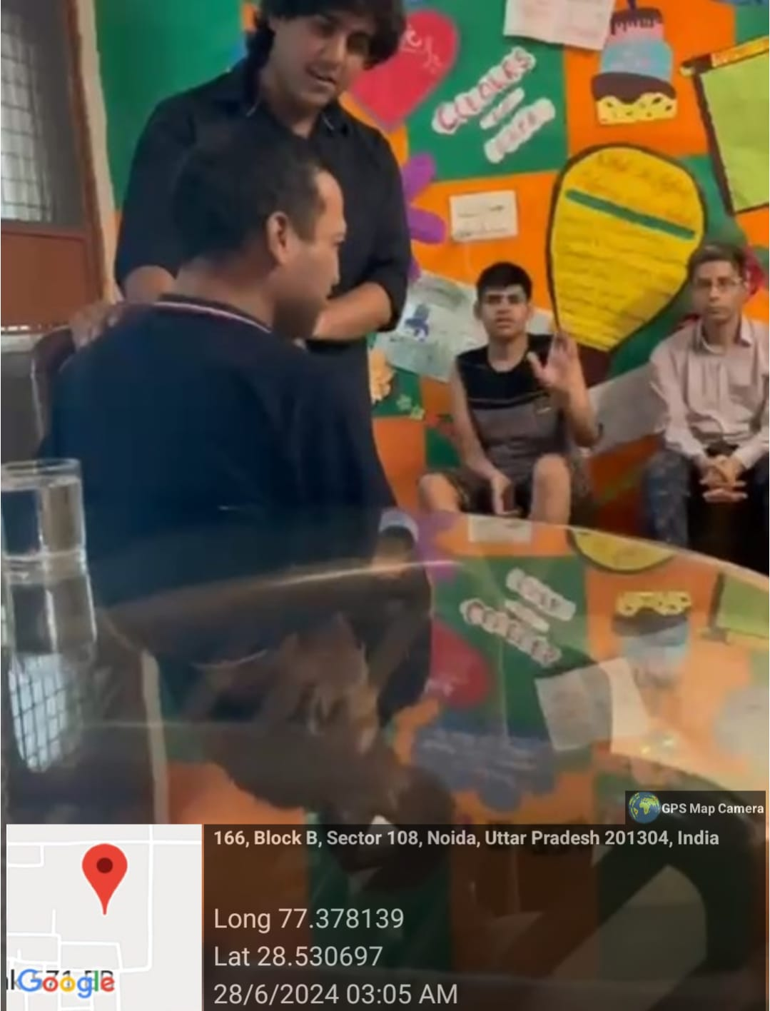

**Conclusion**

My time at Reawakening Wellness Foundation (RWF) has been a deeply transformative and enriching experience. Over the course of four weeks, I was able to immerse myself in the daily operations of an organization that is not only dedicated to mental health recovery but also committed to fostering holistic well-being. This period allowed me to gain valuable insights into the complexities of mental health rehabilitation and the significant role that compassion, community support, and professional care play in an individual's healing process.

From the very first week of orientation to the final week of reflection and feedback, every stage of my journey at RWF was a learning experience. I had the unique opportunity to observe and actively participate in therapeutic practices, ranging from individual counseling sessions to group therapy and recreational activities such as art therapy and mindfulness workshops. These experiences reinforced the critical importance of addressing mental health challenges from multiple angles—emotional, psychological, social, and physical. RWF’s emphasis on creating a safe, inclusive, and non-judgmental space for its clients was particularly impactful, as it demonstrated how an environment of trust can encourage individuals to embark on a path of self-discovery and recovery.

A key takeaway from my time at the foundation was the importance of interdisciplinary collaboration in mental health care. Whether it was working alongside therapists, counselors, administrative staff, or fellow volunteers, it became evident that a multi-faceted approach is necessary for providing comprehensive and effective care. The team-based nature of the work allowed for the pooling of different skills and perspectives, which ultimately benefitted the clients. Participating in team meetings and case study discussions, as well as receiving feedback from supervisors, emphasized the importance of continual learning and adapting to the specific needs of each client. The collective efforts of the team served as a testament to how diverse expertise can come together to create impactful and personalized rehabilitation plans.

On a personal level, this experience has fostered immense growth. Throughout the four weeks, I was consistently challenged to step out of my comfort zone, whether by facilitating group discussions, engaging in role-playing exercises during skill development workshops, or participating in awareness campaigns. Each of these activities strengthened my communication, problem-solving, and empathy skills. Furthermore, the constructive feedback provided by my supervisors and peers has helped me identify both my strengths and areas for improvement, which will be invaluable as I continue to grow professionally and personally.

One of the most rewarding aspects of my time at RWF was witnessing the progress made by the clients I interacted with. Observing their journey from initial apprehension to gradual healing was not only inspiring but also underscored the importance of patient, empathetic care. The resilience displayed by these individuals reaffirmed my belief in the transformative power of therapy and community support. It also strengthened my commitment to mental health advocacy, as I saw firsthand how reducing stigma and creating awareness can make a real difference in people's lives.

In conclusion, my volunteer experience at Reawakening Wellness Foundation has been one of both personal and professional development. It provided me with a deeper understanding of mental health, the importance of holistic care, and the impact of collaborative efforts in rehabilitation. The skills I’ve gained—such as active listening, empathy, and teamwork—are ones I will carry forward into future endeavors, whether in the field of mental health or elsewhere. More than that, this experience has instilled in me a passion for mental health advocacy and a desire to continue supporting efforts that prioritize mental and emotional well-being. I leave RWF with a sense of fulfillment, knowing that I was able to contribute in some way to the important work being done, and with a renewed commitment to making a positive impact in the mental health field.

**CHAPTER 3 TANGIBLE LEARNING**

Participating in the Community Connect course at Reawakening Wellness Foundation (RWF) provided me with invaluable hands-on learning experiences that contributed significantly to both my personal and professional development. The practical nature of this course allowed me to engage directly with clients and professionals in a real-world mental health setting, deepening my understanding of therapeutic techniques and the importance of holistic care in rehabilitation. These experiences offered tangible lessons that I can carry forward into future endeavors.

One of the most significant areas of tangible learning was the practical application of therapeutic techniques. Throughout my time at RWF, I had the opportunity to observe and, in some cases, participate in therapy sessions led by licensed professionals. Witnessing the implementation of cognitive-behavioral therapy (CBT), mindfulness practices, and group therapy provided me with a deeper understanding of how therapeutic models can be tailored to address individual needs. This firsthand experience of therapeutic interventions has given me practical insights into how therapy is conducted, allowing me to connect theory with practice in a meaningful way.

Communication and interpersonal skills were also a major focus of my learning during this course. Engaging with clients, many of whom were dealing with sensitive and complex mental health challenges, helped me develop effective communication techniques. I learned the importance of active listening, patience, and empathy when working with individuals experiencing emotional distress. Whether in one-on-one interactions or group settings, this experience taught me how to foster open and trusting communication, which is essential for building rapport in therapeutic environments. These interpersonal skills will be invaluable in any field that requires understanding and responding to human emotions and behaviors.

Working within the interdisciplinary team at RWF provided another key aspect of tangible learning. The collaborative nature of mental health care was evident throughout my time at the foundation, as I observed therapists, counselors, social workers, and volunteers working together to provide comprehensive care. Being part of this team allowed me to contribute my observations and insights during team discussions on client progress and therapeutic strategies. This experience reinforced the importance of teamwork and collective problem-solving in delivering effective mental health care. The collaborative environment fostered at RWF helped me understand how multiple perspectives and shared expertise contribute to better outcomes for clients.

The course also enhanced my organizational and time management skills. With a variety of responsibilities to balance, from assisting in group therapy sessions to managing client records and contributing to awareness campaigns, I developed a keen sense of how to prioritize tasks effectively. Managing these activities taught me the importance of accuracy, attention to detail, and maintaining confidentiality when dealing with sensitive information. I also learned how to allocate time efficiently, ensuring that deadlines were met and that I could contribute meaningfully to multiple aspects of the foundation’s operations.

Lastly, my involvement in mental health advocacy through RWF’s outreach programs provided tangible insights into the importance of raising awareness in the community. Participating in campaigns aimed at reducing the stigma surrounding mental health gave me real-world experience in organizing and delivering impactful educational programs. This exposure helped me understand the challenges of mental health advocacy while equipping me with practical strategies for engaging the public and spreading awareness. Seeing the positive impact of these initiatives deepened my commitment to supporting mental health causes and advocating for those in need.

In conclusion, the Community Connect course at Reawakening Wellness Foundation has provided me with an array of tangible learning experiences. From gaining practical exposure to therapeutic techniques to developing essential communication, teamwork, and organizational skills, the course has not only expanded my understanding of mental health care but also equipped me with the tools necessary to contribute to future initiatives. These learnings will be integral to my ongoing professional development and my continued advocacy for mental health awareness and support.

**CHAPTER 4 STUDENT’S CONTRIBUTION**

During the Community Connect course at Reawakening Wellness Foundation (RWF), I actively contributed in several meaningful ways that supported both the organization and the clients it serves. As a volunteer, my primary goal was to assist the foundation in achieving its mission of providing holistic mental health care and rehabilitation, while simultaneously gaining hands-on experience and learning valuable skills. My contributions spanned a range of activities, from direct engagement with clients to administrative support and community outreach efforts.

One of my key contributions was assisting in the facilitation of group therapy and skill development workshops. Under the guidance of licensed professionals, I helped organize and lead activities that encouraged clients to express their thoughts and emotions in a safe, supportive environment. My involvement in these sessions allowed me to contribute to the therapeutic process by actively engaging with clients, providing encouragement, and facilitating discussions. By offering a compassionate presence, I was able to foster an environment where clients felt comfortable participating and sharing their experiences, which aided in their overall recovery process.

Another significant area of my contribution was in administrative and operational support. I helped with the preparation and organization of client records, ensuring that client progress was meticulously documented and made easily accessible to therapists and counselors. This administrative work, while behind-the-scenes, played a vital role in maintaining the smooth functioning of the foundation. By ensuring the accuracy and confidentiality of client information, I contributed to the foundation’s ability to provide consistent and effective care. Additionally, I assisted in preparing reports on the outcomes of client sessions, which allowed the team to track therapeutic progress and plan future interventions.

In terms of community outreach, I played an active role in supporting RWF’s advocacy initiatives aimed at raising awareness about mental health issues. I participated in planning and executing awareness campaigns, both online and in the local community. This included helping design informational materials, preparing for mental health awareness workshops, and interacting with members of the community to dispel myths and reduce stigma around mental health. By contributing to these efforts, I was able to support the foundation’s broader mission of promoting mental well-being and encouraging individuals to seek help without fear of judgment.

Throughout my time at RWF, I also took on responsibilities related to program coordination. I assisted in organizing and scheduling activities for clients, including therapeutic art sessions, mindfulness workshops, and social outings. This required collaboration with the foundation’s staff to ensure that the activities were tailored to the clients’ needs and schedules. By contributing to the coordination of these programs, I was able to help create a positive and structured environment that supported the clients’ therapeutic journey.

Lastly, my contribution extended to providing direct emotional support to the clients. As I built rapport with individuals over the course of my time at the foundation, I became a trusted figure to whom they could turn for informal conversations and support. While under the supervision of the clinical staff, I was able to provide a listening ear and offer encouragement to clients who were navigating challenging mental health journeys. This one-on-one engagement contributed to the foundation’s overall goal of creating a nurturing, supportive environment for its clients

In conclusion, my contributions to the Community Connect course at Reawakening Wellness Foundation were varied and impactful. From assisting in therapeutic programs and providing administrative support to participating in advocacy efforts and offering emotional support to clients, I was able to make a meaningful difference in both the operations of the foundation and the lives of its clients. This experience has not only allowed me to contribute to the important work being done at RWF but also enriched my understanding of mental health care and community service.

**CHAPTER 5 CONCLUSION**

The Community Connect course at Reawakening Wellness Foundation (RWF) has been an invaluable experience that has left a lasting impact on both my personal development and my understanding of mental health care. Through my engagement with the foundation, I have gained a comprehensive insight into the critical role that rehabilitation centers play in the lives of individuals facing mental health challenges. The hands-on experiences, direct interaction with clients, and collaboration with dedicated professionals have provided me with practical knowledge that extends beyond textbooks and theoretical learning.

The course allowed me to contribute meaningfully to the foundation’s mission of providing holistic mental health support while simultaneously developing essential skills such as empathy, communication, teamwork, and problem-solving. The therapeutic sessions, workshops, and community outreach programs I was involved in highlighted the importance of approaching mental health care with compassion and patience. I witnessed the profound effect that creating a supportive and inclusive environment can have on an individual’s recovery journey. These interactions reinforced the significance of mental health advocacy and the need to reduce stigma in society.

Furthermore, my contributions to the administrative and organizational aspects of the foundation have deepened my appreciation for the intricate coordination that goes into delivering effective care. Whether it was assisting in the preparation of client records, organizing therapeutic activities, or supporting mental health awareness campaigns, each task demonstrated the collaborative effort required to make a difference in clients’ lives.

In conclusion, the Community Connect course at RWF has been a transformative experience, equipping me with practical skills, a greater understanding of mental health, and a heightened sense of social responsibility. This journey has not only enriched my academic and professional trajectory but has also inspired me to remain committed to mental health advocacy in the future. I leave this experience with a sense of fulfillment, knowing that I was able to contribute to such a meaningful cause while growing as an individual. The lessons and experiences from this course will undoubtedly shape my future endeavors and my continued efforts to support mental well-being.